

MINUTES OF THE KENT RoSPA AGM 10TH OCTOBER 2024
Welcome
The Chairwoman Debbie opened the Annual general meeting of the RoSPA Advanced Drivers and Riders, Kent Drivers Group by welcoming all those present to the meeting and thanking them for giving their time and energy in carrying out the Group activities across the year. She noted that it had been a busy year for the Group and that there was still a need to increase membership. She noted that George Chandler had resigned from the Committee to pursue other interests and thanked him for his work. The meeting then progressed following the agenda attached as Annex 1
Apologies
Apologies for not attending this meeting had been received from Ravi Savur, George Chandler and Hugh Curtis.
Minutes of the 2023 AGM
The minutes of the last AGM of the Group had been circulated and were accepted by those present.
Matters Arising
There were no matters arising from the minutes
Correspondence
Ray advised that correspondence had been received from RoSPA headquarters regarding the Tutors Insurance Policy which had been circulated for comment.
Annual reports
- Chairwoman

Debbie reported that 25 new Associates up from 9 last year have joined and that the Accounts have been audited by Lin Brooks and thanked her for this much appreciated work.
She reported that the income of the Group has kept up with expenditure and that the way forward was to keep the incomings and outgoings even whilst keeping in line with RoSPA policies. Debbie stressed the need to keep members and encourage Associates to take the test and become members once they have passed. There was a need to find new Associates and asked for members to encourage family, friends and acquaintances to join.

- Treasurers Report
Deepak presented the report attached as Annex 2 showing the last year total was £4,190.10 and this year it was £4,389.98. He gave a description of his role and stated it had been a great pleasure extending also his thanks to Lin Brook for the Audit. A proposal was made to accept the Accounts by Richard Powell and seconded by Pat Tilly. Ray requested a breakdown of the Tutor training costs and Deepak said this would be provided.
- Presentation of Budgets
Debbie presented the Associate budget for 2024/5 based on 25 new Associates joining the Group shown in Annex 3. The training team suggested that there should be a set route for the demonstration drive. There was discussion on areas where costs could be reduced, the only one was the reduction of the mileage on the demonstration drive, bearing in mind that the attention span and memory to learn facts, diminish with time. It was suggested that the 71 mile routes were too long and a reduction of this figure could allow a reduction in the Associate fee.
Debbie said that perhaps we should consider reducing the associate fee from £75.00 to £60.00 but was reminded by John that we had the mandate to the £75.00 increase and nothing else should be discussed at this meeting.
Pat Tilly made a valid concern about the impact of increasing the fee to £75.00 for our young associates – he currently has a 19 old young man who could not have afforded £75.00, the chairwomen clearly was not think about young drivers, she made it seem that all new associates irrelevant of age will not pay £75. (Please note, that the secretary later advised Pat, that the young driver’s membership fee has not changed)
Ken Horn made a valid point of asking what other groups charge, clearly this was not explored before we reach the increase to £75.00 (Please note, that the budget was set on actual figures, the amount it cost the group to have a demonstration drive, if everyone claimed the full entitlement)
There was some discussion around this subject as to whether the high fee would deter Associate recruitment, reducing new members and could new Associates afford it. A straw poll was then held with those at the meeting that showed only one was against the increase to £75.
- Events
John provided the report attached as Annex 4 outlining the events which had comprised monthly meetings with guest speakers and a Skid Pan training event. There were events being planned for 2025 and John advised that he would like to handover to a new Events
Coordinator if one can be found.

- Membership Secretary
Ian provided the report attached as Annex 5 showing membership had risen from 82 – 89 which was still down from 91 prior to Covid. This showed a slow steady increase.

- Training Officer
Ray provided the report attached as Annex 6 outlining the struggle to get new associates on average two a month, re-affirming the need for new recruitment.

This year has been another that we have struggled to attract new Associates which is highlighted by the low number of associates taking the test. On average we are getting 2 new associates per month. Last year we started the Introduction Sessions , this has proved a success as we currently have no associates waiting to be assigned a Tutor ~ previously we always had 14 associates waiting to attend the Induction Seminar.

Associates
- 4 x Gold Pass ~ 1 last year
- 1 x Silver Passes ~ 3 last year
- 0 x Bronze Pass ~ 1 last year
- Tutors
- 8 x Approved Tutor ~ 10 last year , 2 left and 1 new Tutor
- 4 x Advanced Tutors ~ 4 last year 1 left

Tutor Training
Nothing to report on
Ray said that without tutors there would be no group and thanked all the the tutors for the hard work they do on behalf of the group.

- Secretary report
Only one communication from HQ Tutors Insurance policy. Thanks were extended to Ray for all his work over the year.
Election of Committee Officers
Those in position on the Committee agreed to continue with their roles and were thanked by Debbie on behalf of the Group for all their good works across the year.
Any other notified business
Ravi had asked members what they want from the Group Newsletter and whether they would be willing to contribute.
Close AGM Debbie closed the AGM by thanking all those who had attended and the Committee Members and tutors for their sterling work over the year.
Signed 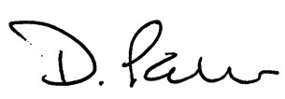
Deborah Palmer Chairwoman
Dated 18.10.24

ANNEX 1
AGENDA FOR THE RoSPA AGM 10TH OCTOBER 2024

Venue: Aylesford Village Community Centre, Forstal Road, Aylesford Kent

Welcome
Apologies
Minutes of the 2023 AGM
Matters Arising
Correspondence
Annual reports
  - Chairwoman

  - Treasurers Report

  - Presentation of Budgets

  - Events
e Membership Secretary
f Training Officer
g Secretary
Election of Committee Officers
Any other notified business
Close AGM
Committee Members
Debbie Palmer Chairwoman
Deepak Deshmukh Treasurer
Ian Russsell Membership Secretary
John Corcoran Events Co-Ordinator
Ray Davies Training Officer
Richard Powell Social Member
Ken Horn General Member
Ravi Savur News Letter Editor
Harry Debling Social Member
David Palmer Temporary minute secretary
Treasures Report.
On behalf of Madam Chair and the committee, it has been a great pleasure for me once again to serve as your Group Treasurer.
As a treasurer, my key responsibilities are
To monitor and manage Group’s Income and Expenditure
To keep monthly record of monies in and out, leading to preparation of draft Annual Accounts
To arrange independent external audit of Annual Financial Summary Accounts.
To keep the Chair and the Committee informed on all financial matters, by regular attendance at Committee meetings at 3/12 intervals.
To advise and make recommendations for efficiency savings in all financial aspects.
To maintain regular liaison with Metro Bank and our Business manager dealing with any correspondence and changes as necessary.
As much as it gives me pleasure to say that this year, we have managed to keep our Expenditure in check with our closing balance of £4389.98 @ 31.08.24, which is only marginally above the opening balance of £4192.00 as @ 1.9.23.
Our average monthly income was approx. £245/month
Whereas our average monthly Expenditure was approx. £233/month
However, both Debbie and I feel that recently expressed concerns by some Committee members, our finances needed careful analysis on various fronts such as:
Our Membership Fee Structure
Recruitment and Retention of new members
Response to new style of Induction by new Associates
Health of our finances with a view to future development and progress of the group.
As a result, Debbie is going to explain some of our proposal, but before that I would like to take this opportunity to present the audited accounts for the year ending 31.08.24 for adoption.
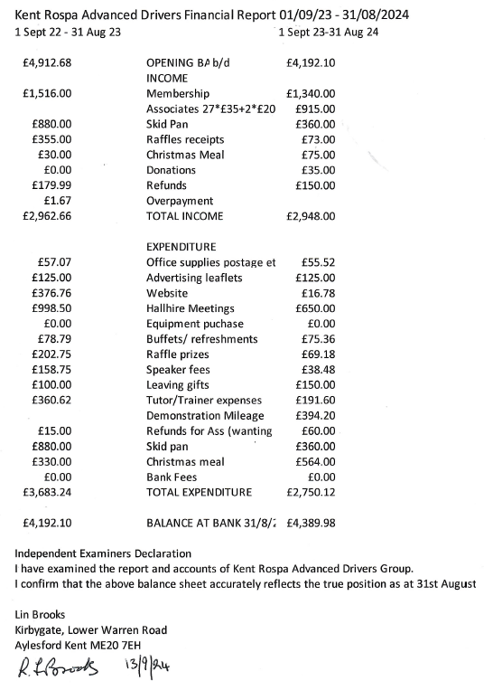

Associate Budget for 2024-2025 Expenses Income Current
Associates Costs working on 25 associates @£75 1875.00
Current Income 22x£35+ 2x£20 810.00
Expenses
Demo Drives of 71 miles @ 40p per milex25 700.00 399.20
Refreshments @£8x25 200.00 0.00
Tutor Training at £50 claimx6x2 600.00 171.20
Advanced Tutor test x1 50.00 0.00
Leaflets £125@10% inflation 137.00 125.00
Website Costs 77.00 77.00
Tutor Meetings Hall 2hrsX£20x2 80.00 0.00

Total 1844.00 1875.00 772.40
Budget for members using 01.09.23 to 31.08.24 figures
Budget Current Budget Current
Expenses Expenses Income Income
Income
Members 30 x£30 900.00 1140.00
Committee members &
Tutors x20 @ £10 200.00 200.00

Expenses
Hall Hire
Social 2.5 hours @ £20 x12 550.00 570.00
Meetings 2 hours @ £20 x3 120.00 80.00
Refreshments £20 x12 240.00 75.36
Office Costs 150.00 55.52
Bank Charges £10x12 120.00 0.00
Capital Expenditure 150.00 0.00
1330.00 780.88 1100.00 1340.00

RoSPA Advanced Drivers and Riders
Kent Drivers Events Report 2023-24
Topic | Date |  | Speaker | Attendees
Issue Affecting the Traffic and Roads Agenda | 14th September 2023 |  | Graham Feest | 16
Annual General Meeting | 12th October 2023 |  | Auriel Wetherall | 12
The Real Blood Runners | 9th November 2023 |  | Trevor Sayer | 16
ANPR | 14th December 2023 |  | Chris Oliver-Jones | 22
The Highway Code | 11th January 2023 |  | Will Purse | 25
From Carburettor Driven to Computer Driven |  | 8th February 2024 | Peter Mandell | 19
Gem Motoring Assist |  | 14th March 2024 | James Luckhurst | 13
Skid Pan Training |  | 20th April 2024 | All Motor Training | 5
Parking |  | 11th April 2024 | George Chandler | 14
NextBase dash Cams |  | 9th May 2024 | Richard Peak | 13
How to teach a car to drive |  | 13th June 2024 | Rebecca Hills | 16
Meet the Examiner |  | 11th July 2024 | Chris Hanney | 23
Attendance at a couple of our monthly meetings was a bit on the low side but the rest have been good, the average has been 16.1 where previous year it was 15.1.
We have been inviting Kent IAM to help boost numbers which has worked quite well. We encourage you to bring along family & friends.
As well as our monthly meetings we organised 1 external Skid pan training event. We hope to do more later this year and in the spring.
We now working on the 2004-5 programme of speakers. We will be broadening the topics and speakers by inviting speakers to present on non-motoring topics. Hopefully this will improve attendance.
We have bookings confirmed for November, December, January, March, April, May and June, we are waiting confirmation for February, July and September.
We are organising a visit to the Highways England Control Centre at Godstone. Awaiting Dates.
We are still looking for a new events co-ordinator, it’s time for me to hand over.
If you have a subject or topic, even non motoring, you would like to hear about do let us know and see what we can arrange.
John Corcoran
Events co-ordinator.

ANNEX 5
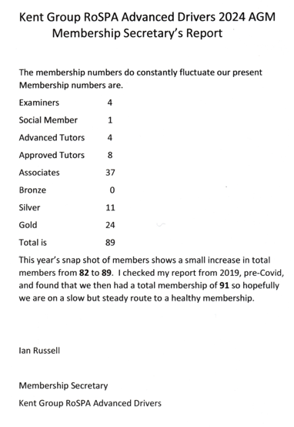

Training officers Report
This year has been another that we have struggled to attract new Associates which is
highlighted by the low number of associates taking the test.
On average we are getting 2 new associates per month. Last year we started the Introduction Sessions, this has proved a success as we currently have no associates waiting to be assigned a Tutor, previously we always had 14 associates waiting to attend the Induction Seminar.

Associates
- 4 x Gold Passes ~ 1 last year
- 1 x Silver Pass ~ 3 last year
- 0 x Bronze Pass ~ 1 last year
- Tutors
- 8 x Approved Tutors ~ 10 last year , 2 left and 1 new Tutor
- 4 x Advanced Tutors ~ 4 last year 1 left

Tutor Training
Nothing to report on
Ray said that without tutors there would be no group and thanked all the tutors for the hard work they do on behalf of the group.

